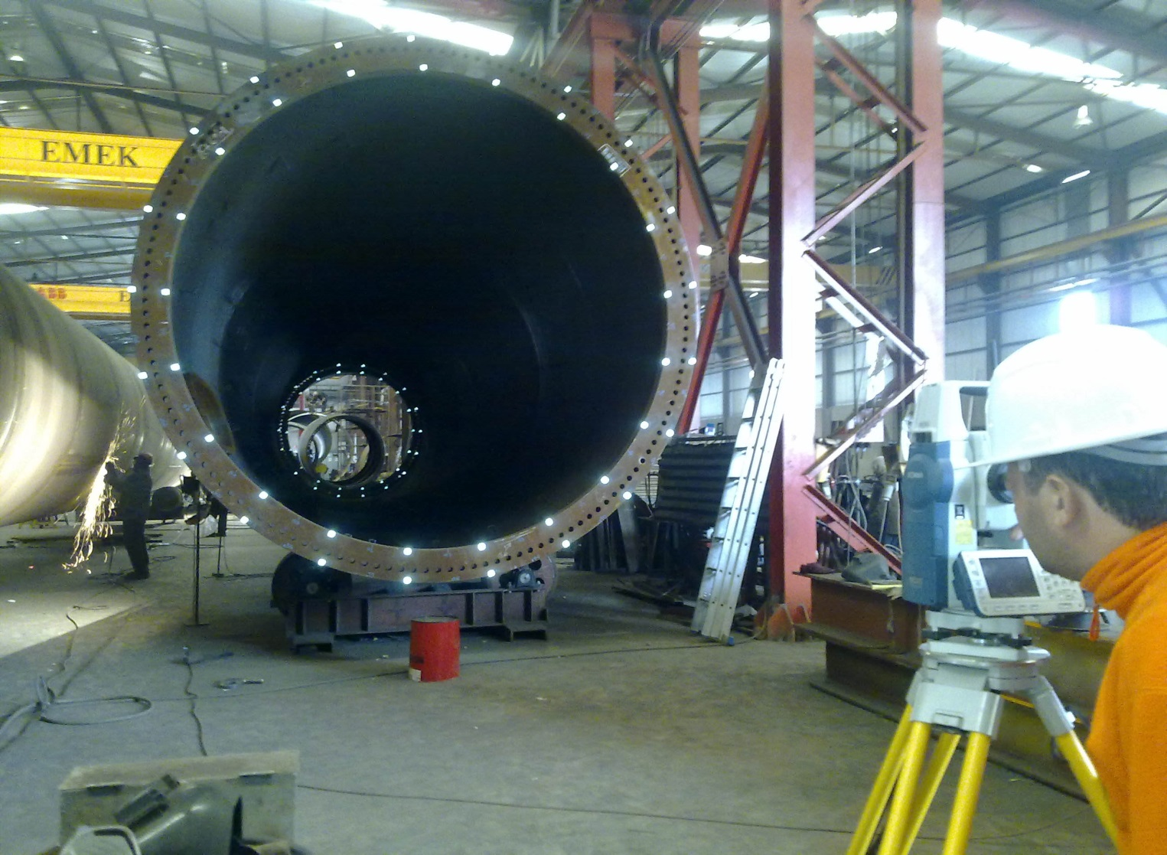

INDUSTRIAL SURVEYING

3

3

3

3

High Pressure Natural Gas and Regulating Station, Tema, Ghana

3

3

INDUSTRIAL SURVEYING

INDUSTRIAL SURVEYING

3

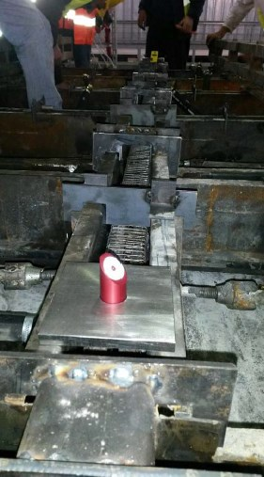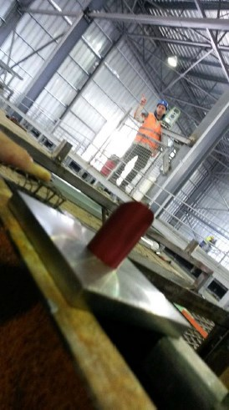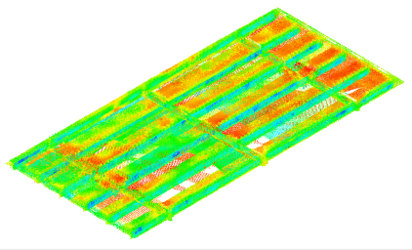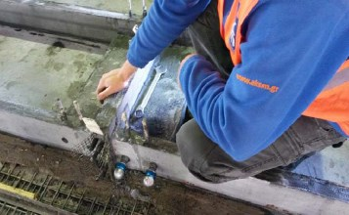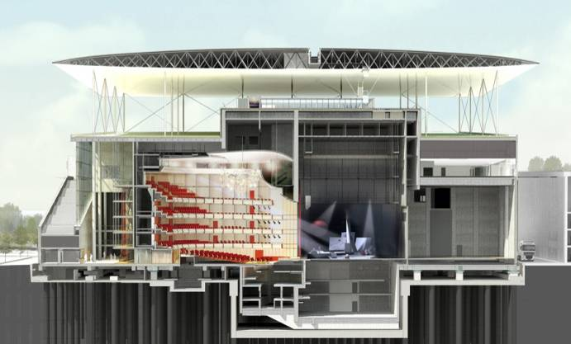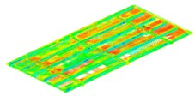

* GEOMETRY VERIFICATION PRIOR TO ERECTION

For each unit a fully referenced registry report was created by using 3D Laser Scanning Techniques. Each panel was evaluated on its constructed geometry:

* Curvature of the casted slab
* Slab thickness
* ER points coordinates deviation in relation to As-Built values
* Ribs, Beams width and CL
* CANOPY ERECTION

1. Network Establishment

A high accuracy network (sd <1 mm), was established on the Roof of the Opera Building consisting adequate in number and distribution on the area of interest and finally determined in geometry and position in relation to the density of the scaffoldings. In total 90 benchmarks for CCR prisms were established and incorporated to the main network.

1. Panels erection

Preliminary installation took place with measurements performed on the other side of the panel. Then each panel was adjusted on its final position by measurements performed on the inner side (installation of control points).

Finally each panel was examined for its final position in relation to the adjacent, in order to fulfill the erection criteria.

1. Bracings (metal structure) installation.

Each part of the internal steel structure mas modified according to the as- built model provided to the designer. Final adjustments were performed by measurements.

1. Upper skin installation

Each top skin panel was preliminary positioned by the use of the bracings calibrated.

Then the final adjustment took place by using the control points established during preconstruction.

INDUSTRIAL SURVEYING

7

5

www.aksm.gr